ASSIGNMENT NO. 6
Implementation of Linear Regression

Aim
To implement linear regression to predict a continuous value and check how good the predictions are.

Objectives
- Understand how linear regression fits a straight line through data.
- Find the slope and intercept of the best fit line.
- Predict values for new inputs.
- Evaluate the model with MSE and the R² score.

Software and tools
Python 3, written and run in Jupyter Notebook (VS Code works too) on Windows. Libraries used: numpy, matplotlib and scikit-learn.

Theory

1. What regression is
Classification predicts a category, like spam or not spam. Regression predicts a number: a house price, a temperature, a mark out of 100. Linear regression is the simplest kind. It assumes the output changes along a straight line as the input changes.

2. Simple linear regression
With one input, the model is the straight-line equation we all learned in school:
y = m·x + c
y is the output and x is the input. m is the slope, which says how much y changes when x goes up by 1. c is the intercept, the value of y when x is 0.

3. Multiple linear regression
With more than one input, the idea stays the same:
y = b₀ + b₁x₁ + b₂x₂ + … + bₙxₙ
Every input gets its own coefficient (b₁, b₂ and so on), and b₀ is the intercept.

4. Finding the best line
Lots of lines could pass through the data, so we need a rule for picking one. Linear regression uses least squares. Each point's error is the gap between its real value and the line, and the best line is the one with the smallest total of squared errors. For one input, the slope and intercept come straight from these formulas:
m = Σ (x − x̄)(y − ȳ) / Σ (x − x̄)² c = ȳ − m·x̄

5. Measuring the fit
Metric | Formula | Meaning
MAE | Σ |y − ŷ| / n | Average size of the error
MSE | Σ (y − ŷ)² / n | Average squared error, punishes big errors more
RMSE | √MSE | Error in the same unit as y
R² score | 1 − Σ(y − ŷ)² / Σ(y − ȳ)² | Share of the variation the model explains (1 is perfect)

6. Assumptions
- The relation between input and output is a straight line.
- The errors don't depend on each other.
- The errors are spread about equally for every value of x (homoscedasticity).
- The errors are roughly normally distributed.
- With several inputs, the inputs shouldn't be strongly correlated with each other (no multicollinearity).

Dataset used
To keep things easy to follow, we made up a small dataset of 20 students with two columns: hours studied and marks out of 100. Hours is the independent variable and marks is the dependent one. 16 students went into training and 4 into testing.

Procedure
- Import numpy, matplotlib and the scikit-learn modules.
- Create the hours and marks arrays and reshape hours into a 2D array.
- Split the data into 80% training and 20% testing.
- Fit a LinearRegression model on the training data.
- Print the slope, intercept and final equation.
- Predict marks for the test data and compare them with the real marks.
- Calculate the MSE and R² score.
- Predict the marks for a new student and plot the best fit line.

Program
# Assignment 6 - Linear Regression
import numpy as np
import matplotlib.pyplot as plt
from sklearn.linear_model import LinearRegression
from sklearn.model_selection import train_test_split
from sklearn.metrics import mean_squared_error, r2_score

# small dataset: hours studied vs marks scored (20 students)
hours = np.array([1.1, 2.0, 2.5, 3.2, 3.5, 4.0, 4.5, 5.1, 5.5, 6.0,
6.5, 6.9, 7.4, 7.8, 8.3, 8.9, 9.2, 9.6, 2.7, 5.8])
marks = np.array([21, 30, 28, 40, 38, 45, 48, 55, 60, 62,
66, 72, 75, 80, 82, 88, 91, 95, 33, 61])

X = hours.reshape(-1, 1) # sklearn wants a 2D input
y = marks

X_train, X_test, y_train, y_test = train_test_split(X, y, test_size=0.2, random_state=0)

model = LinearRegression()
model.fit(X_train, y_train)

print("Slope (m):", round(model.coef_[0], 3))
print("Intercept (c):", round(model.intercept_, 3))
print(f"Equation: marks = {model.coef_[0]:.2f} * hours + {model.intercept_:.2f}")

y_pred = model.predict(X_test)
print("\nActual vs Predicted on test data:")
for a, p in zip(y_test, y_pred):
print(f" actual = {a:3d} predicted = {p:.1f}")

print("\nMSE:", round(mean_squared_error(y_test, y_pred), 3))
print("R2 score:", round(r2_score(y_test, y_pred), 3))

# predict for a new student
print("\nPredicted marks for 7.5 hours of study:",
round(model.predict([[7.5]])[0], 1))

plt.figure(figsize=(6, 4))
plt.scatter(X, y, label='Actual data')
line_x = np.linspace(0, 10, 50).reshape(-1, 1)
plt.plot(line_x, model.predict(line_x), color='red', label='Best fit line')
plt.xlabel('Hours studied')
plt.ylabel('Marks')
plt.title('Hours vs Marks (Linear Regression)')
plt.legend()
plt.tight_layout()
plt.savefig('a6_line.png')
plt.show()

Output
Slope (m): 8.93
Intercept (c): 8.882
Equation: marks = 8.93 * hours + 8.88

Actual vs Predicted on test data:
actual = 33 predicted = 33.0
actual = 30 predicted = 26.7
actual = 61 predicted = 60.7
actual = 60 predicted = 58.0

MSE: 3.683
R2 score: 0.983

Predicted marks for 7.5 hours of study: 75.9

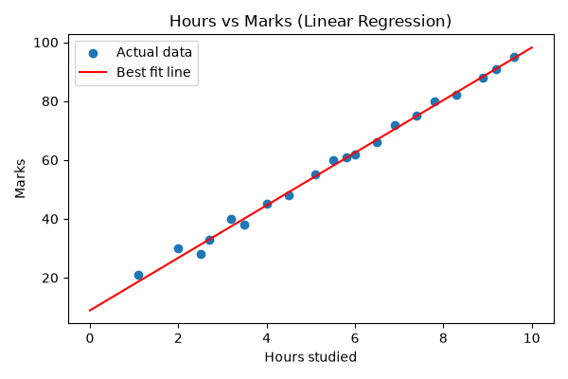
Figure 6.1: Data points and the best fit line

Observations
- The model found marks = 8.93 × hours + 8.88.
- A slope of 8.93 means each extra hour of study adds about 9 marks on average.
- The intercept, 8.88, is the predicted mark for zero hours. It's just where the line starts, so it shouldn't be read too literally.
- Test predictions landed close to the real marks. The biggest miss was about 3.3 marks.
- R² is 0.983, so the line explains about 98% of the variation in marks. MSE is only 3.683.
- A student who studies for 7.5 hours is predicted to score about 75.9.

Conclusion
Linear regression found a clear positive link between study hours and marks, and the high R² shows the straight line fits this data very well. It's quick to build and easy to explain, which is why it's usually the first model people try when the output is a number.

